 | 26.14.6 Editors - Properties Editor - Object Data Properties Tab - Point Cloud Object
Table of content
Attributes panel 1
Attributes Index 1
Attribute name 1
Drag Handler 1
Search Field 1
Invert 1
Sort by Name 2
Add + 2
Remove - 2
Attribute Specials menu 2
Convert Attrribute 2
Data Type 2

Attributes panel
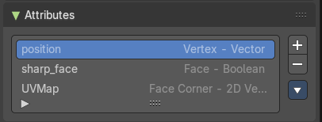
A list of the attributes at this object. Attributes can be used to identify an object in the shader editor or the geometry nodes editor.

Attributes Index
A List of the attributes for this mesh.

Attribute name
The name of the attributes. It can be renamed by double clicking at it.

Drag Handler
The two vertical lines at the end is a handler with which you can expand the list.

Search Field

You can expand a search field at the bottom of the list. Type in your term and hit enter to filter for your term.

Invert
Exclude the search term instead of searching for it.

Sort by Name
Sort the List by name.

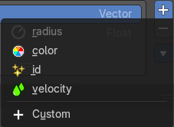
Add +
Create a new attribute. You can choose between predefined attributes. Or generate a custom one.

Remove -
Delete the selected attribute.

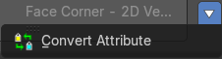
Attribute Specials menu

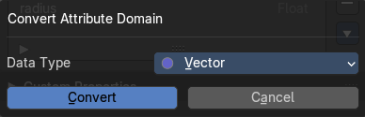
Convert Attrribute
Change how the selected attribute is stored.
This operator opens a popup menu where you can change the settings of the attribute.

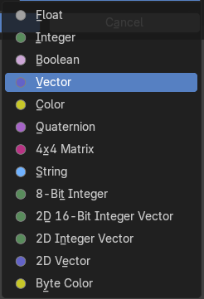
Data Type
Just Generic. What data type to use for the attribute calculation.

